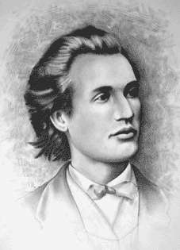

Barem de corectare clasa a V-a

- 662314 ................................................. 5p
- 7.............................................................5p
- 202 ........................................................5p
- 2214......................................................5p
- 8 probleme ..........................................5p
- 9037.....................................................5p
- 51..........................................................5p
- ${\text{162}}^{7}<{\text{54}}^{\text{10}}⋅2^{4}<{\text{18}}^{\text{15}}$.......................5p
- 39 ani ...................................................5p
- 0 ...........................................................5p
SUBIECTUL II
- Torema impartirii cu rest;
$\overline{\text{abcd}}=(a+b+c+d)⋅\text{332}+r,$ $r<a+b+c+d$...............................3p
Valoarea maxima a sumei celor patru cifre este 36,
deci resturile posibile pot fi 16 si 25..........................................................3p
Daca restul este 16, catul este 17..............................................................1p
$\text{332}⋅\text{17}+\text{16}=\text{5660}$, nu verifica.............................................................3p
Daca restul este 25, catul este 26.............................................................1p
$\text{332}⋅\text{26}+\text{25}=\text{8657}$..............................................................................2p
nr. cautat este: 8657................................................................................2p

